**Installation steps for VTIGER 5.4.0:-**

**Step 1:** Download and double click on vtiger

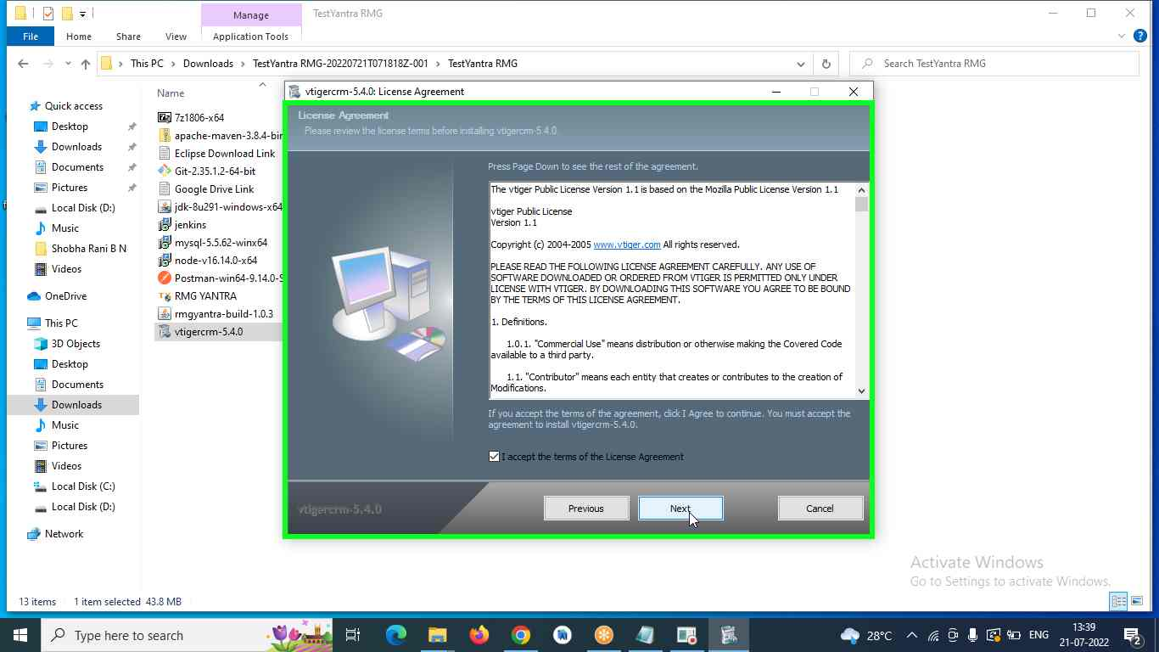

**Step 2:** enter **root** and click on **next**

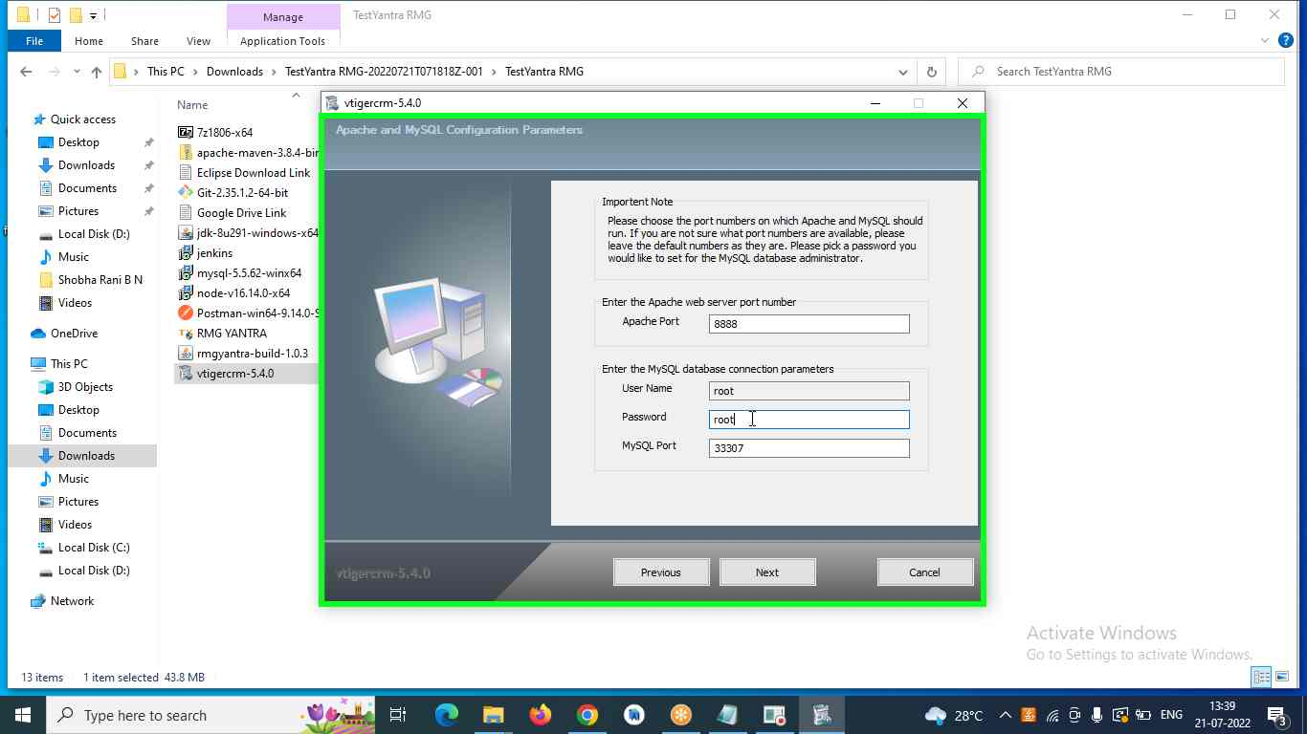

**Step 3:** enter **admin** as password,[**abc@gmail.com**](mailto:abc@gmail.com)as Emailand click on **next**

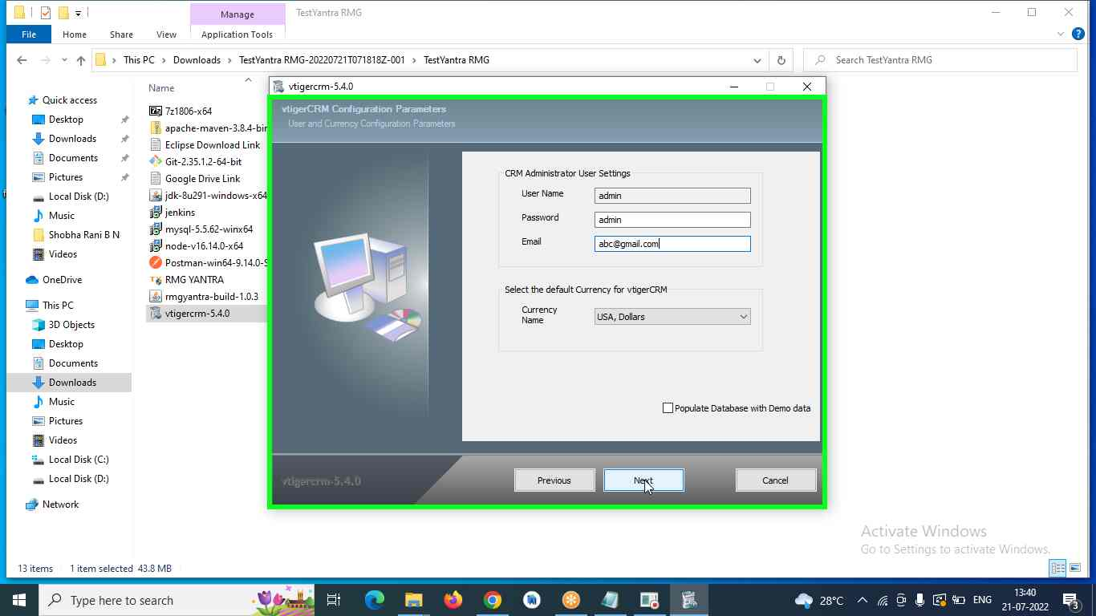

**Step 4:** click on **next**

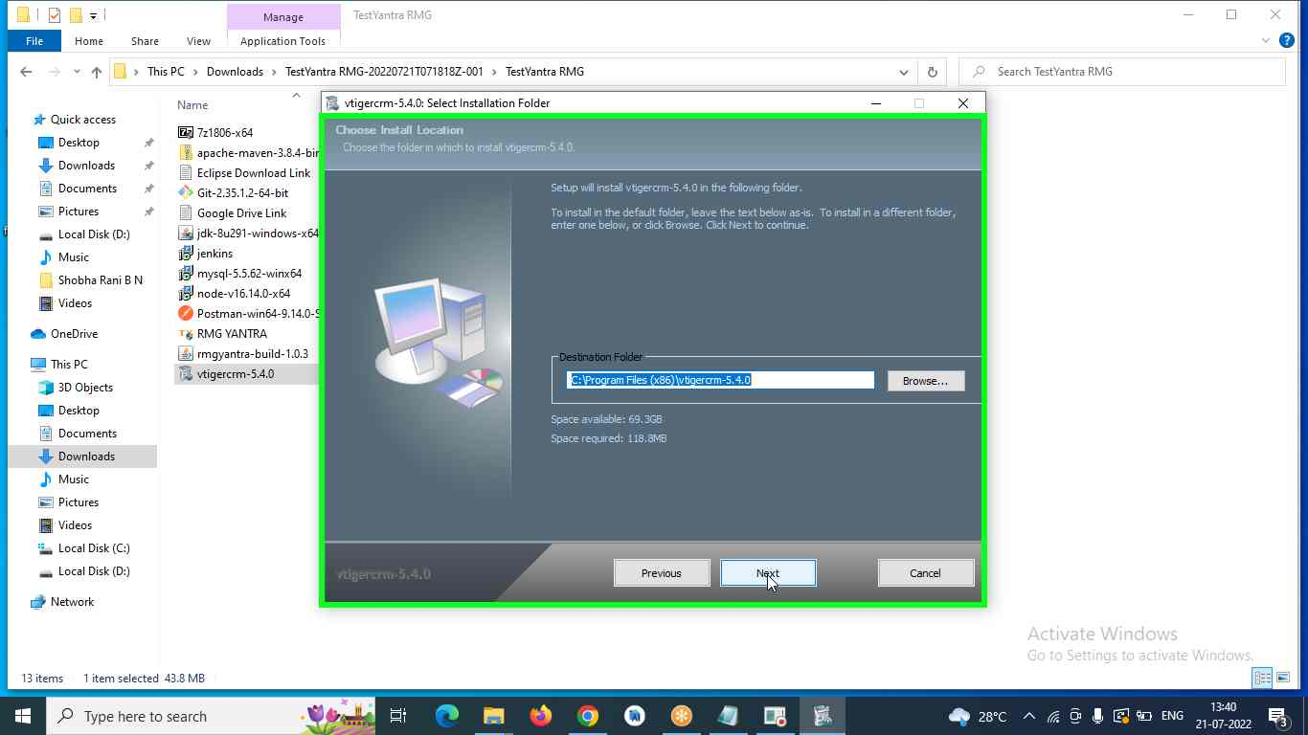

**Step 5:** click on **next**

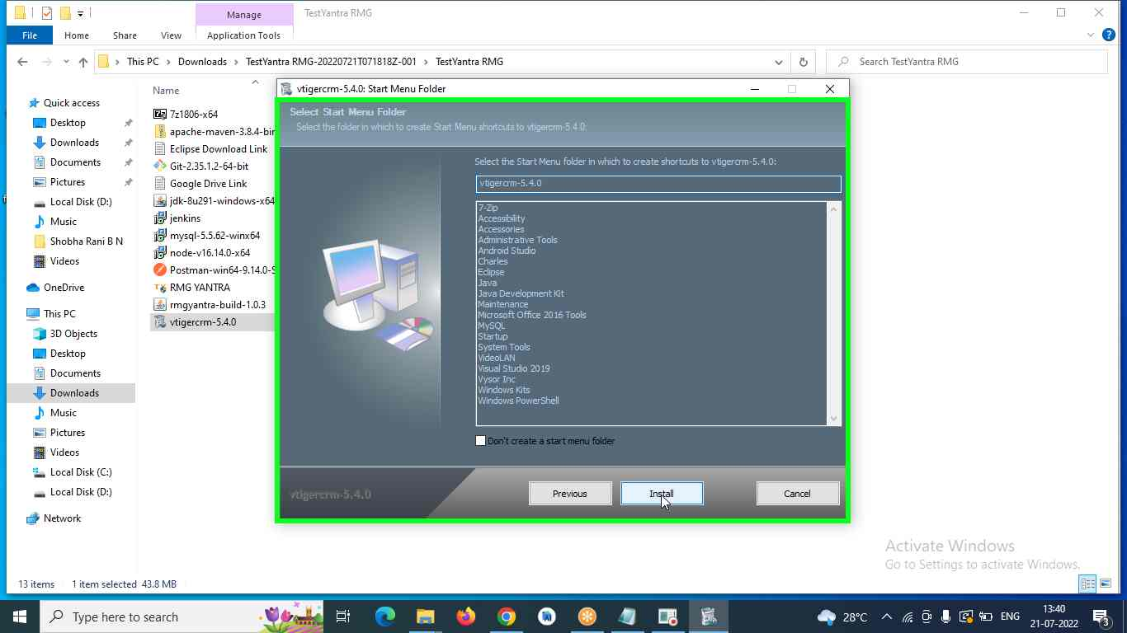

**Step 6:** click on **Allow Access**

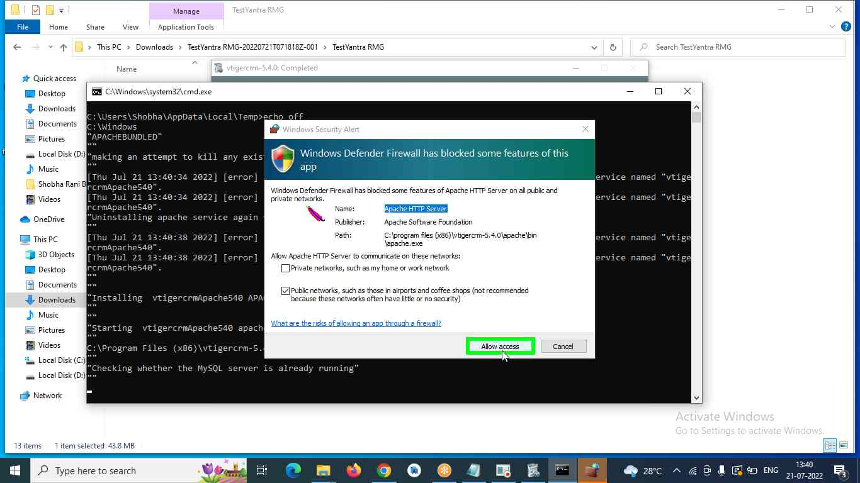

**Step 7:** Don’t close any window, It will take the time and popup below screen in default browser

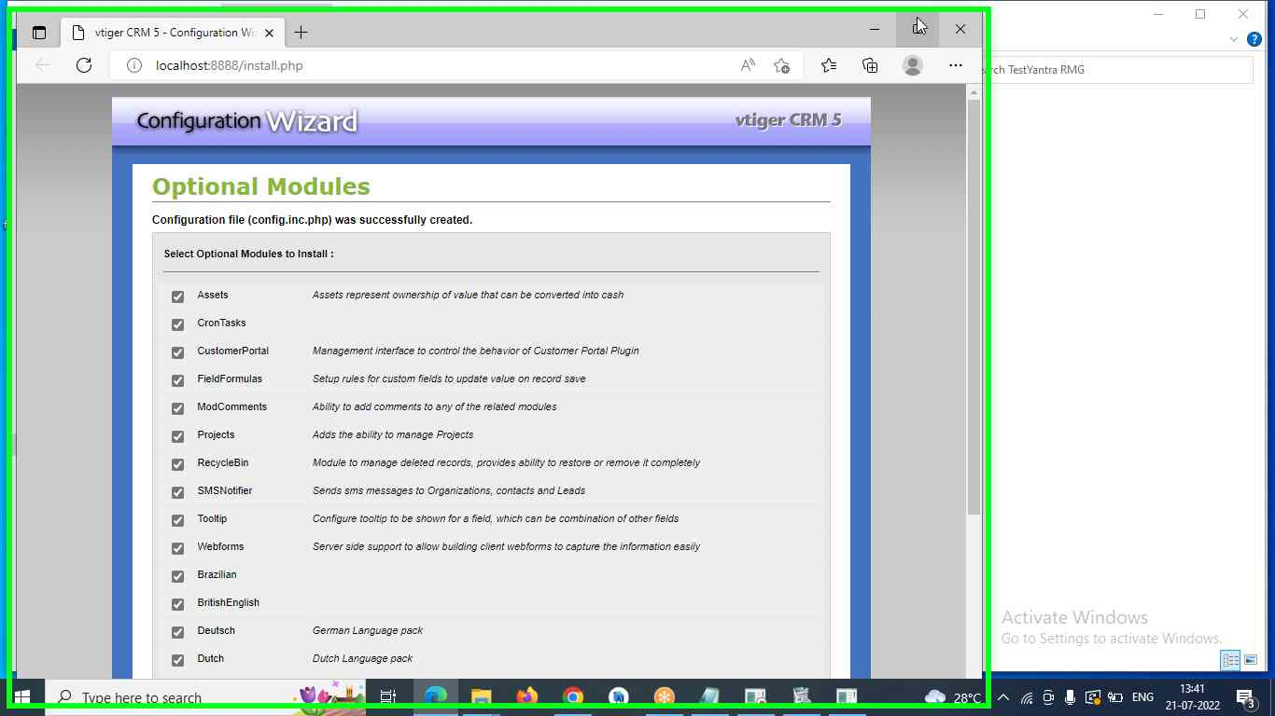

**Step 8:** Scroll down and click on **next**

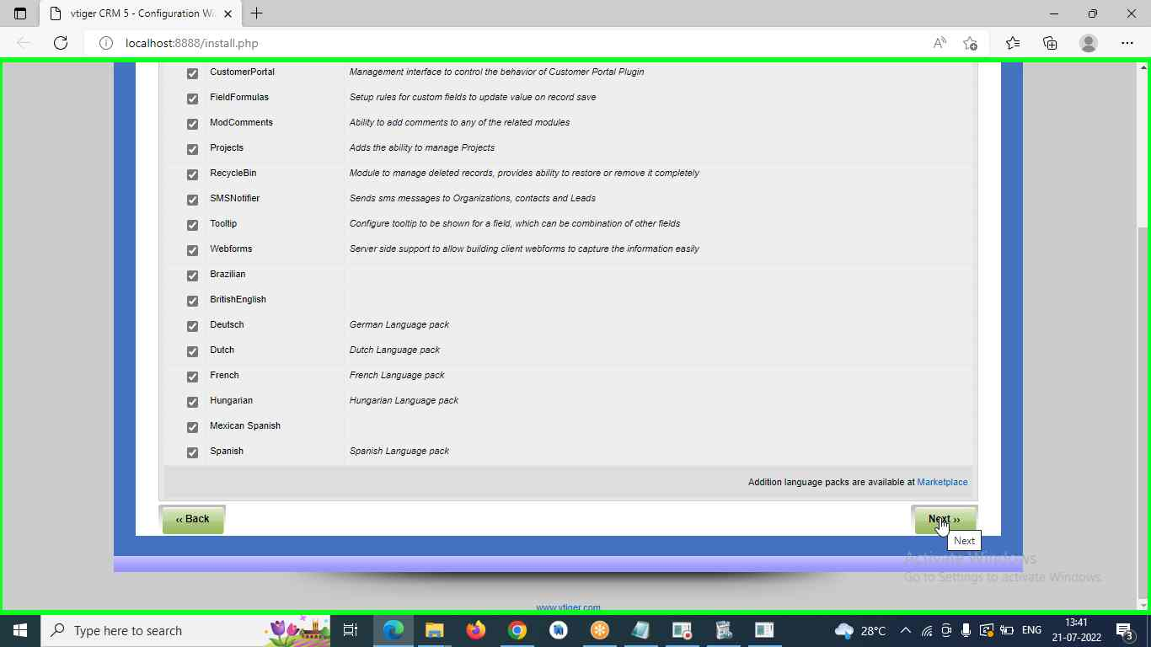

**Step 9:** after that it will take the time to configure based on the computer clock speed

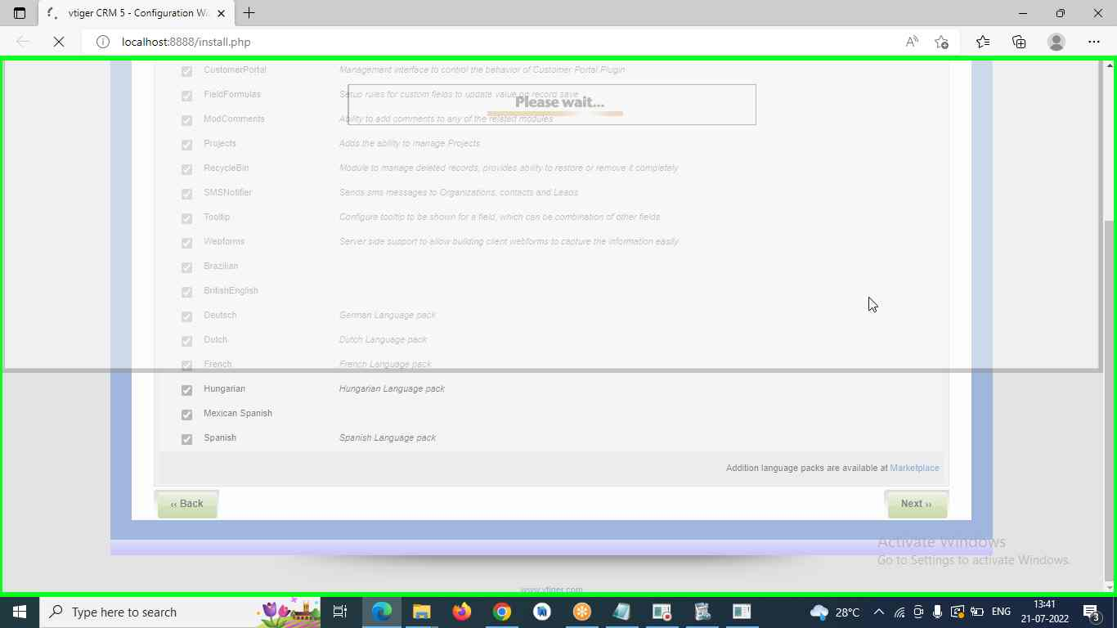

**Step 10:** click on **Finish**

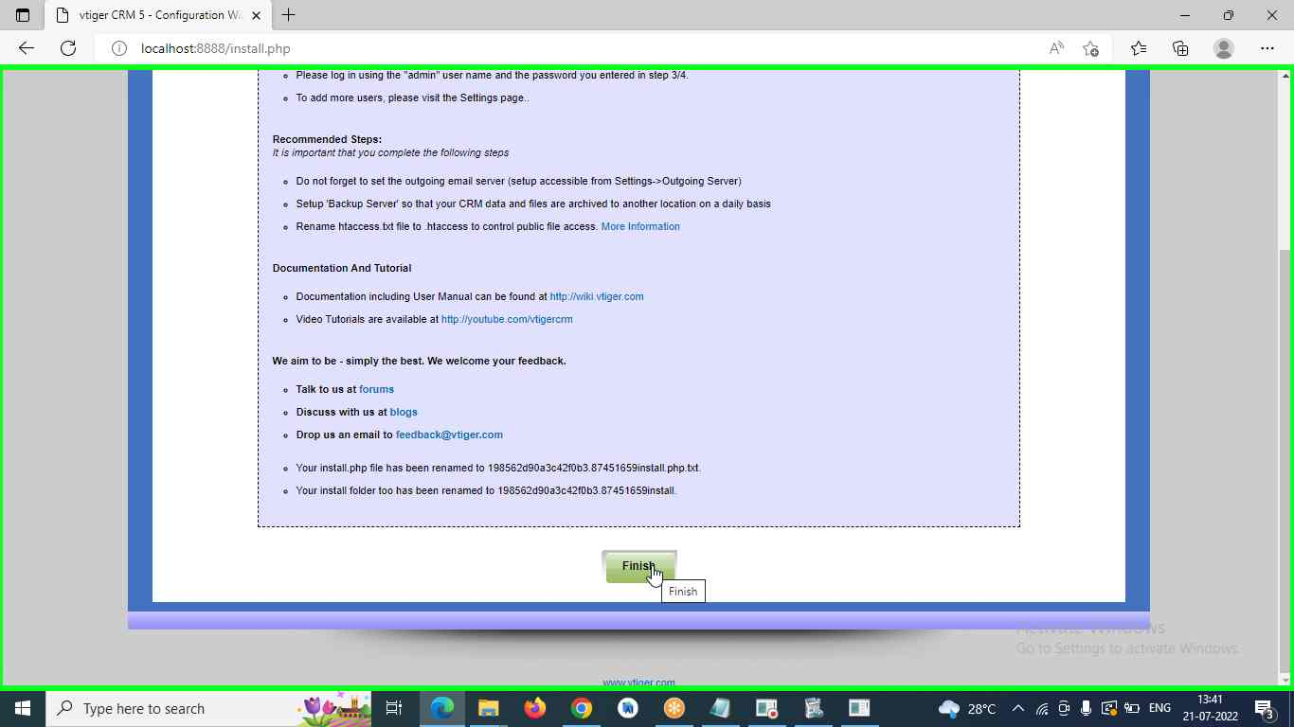

**Step 11:** Enter the url as <http://localhost:8888> and enter username as **admin** and password as **admin,** click on **Login** button

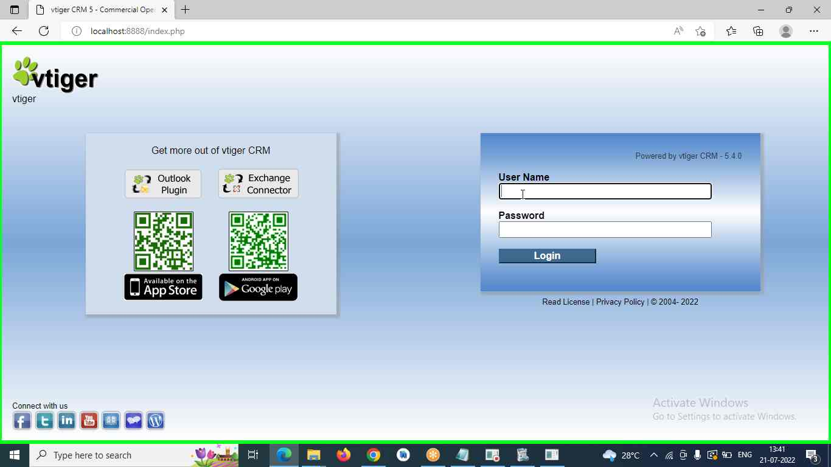

**Step 11:** Below screen is the **Homepage** of the Vtiger

